**Project 7:**

**Creating an EC2 instance in custom VPC**

Task1: Create a VPC

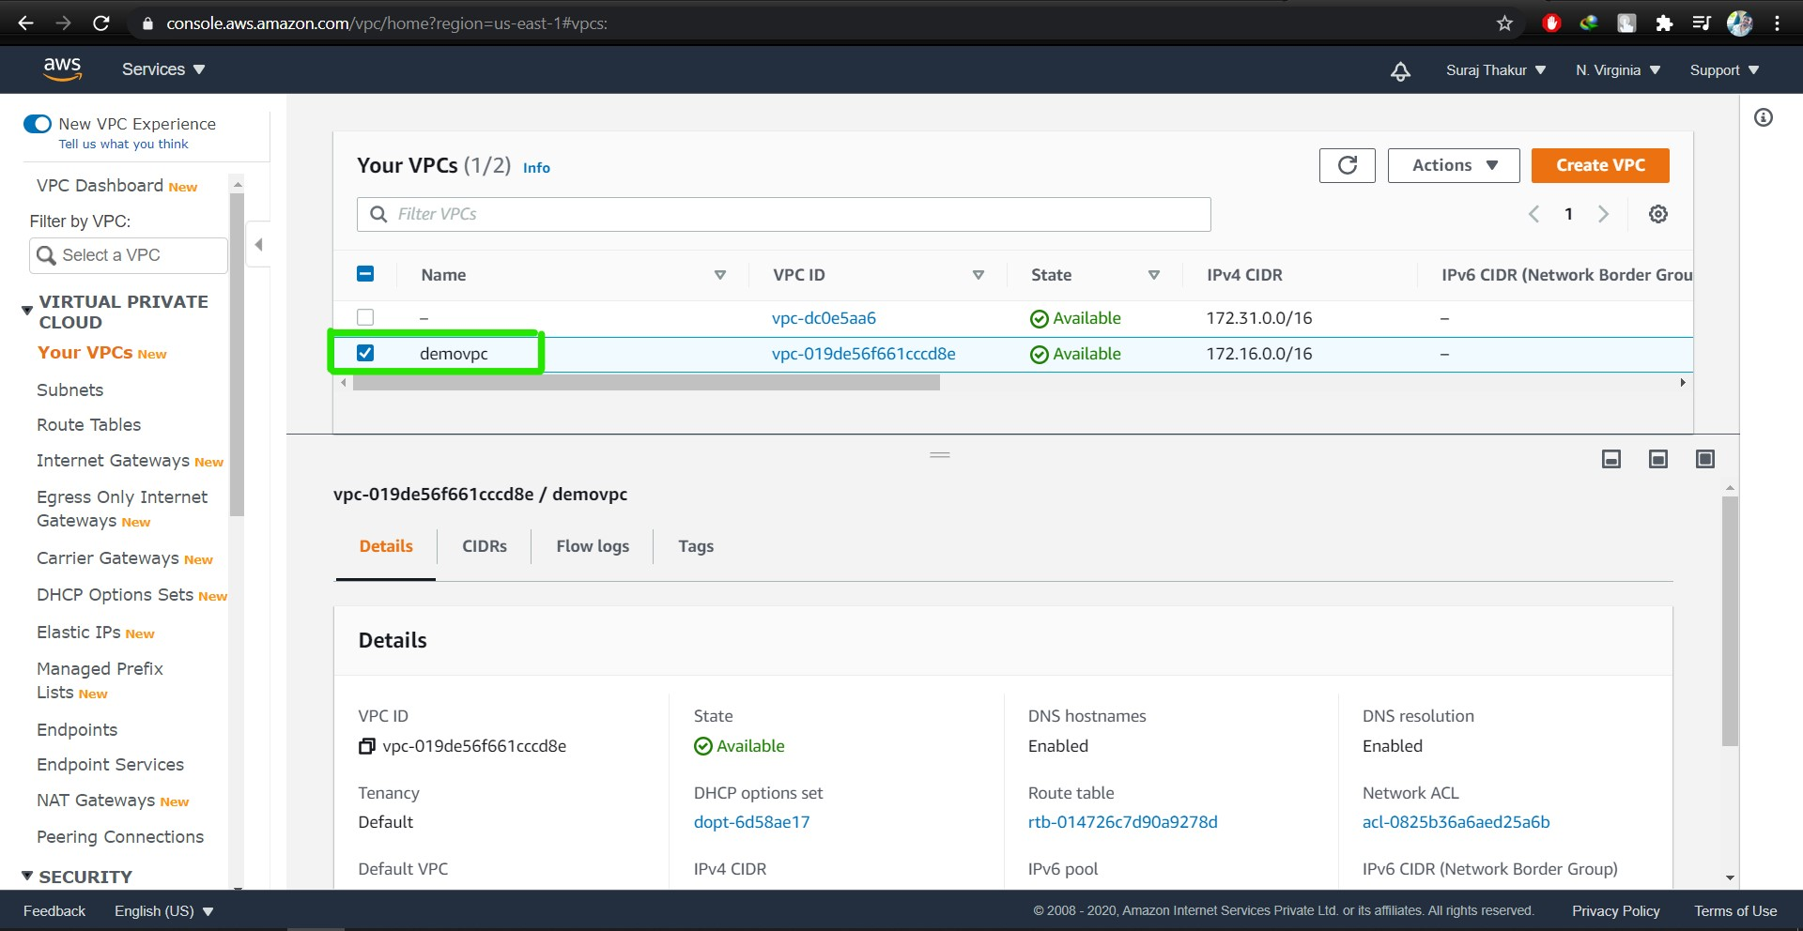

Task 2: Create an Internet gateway

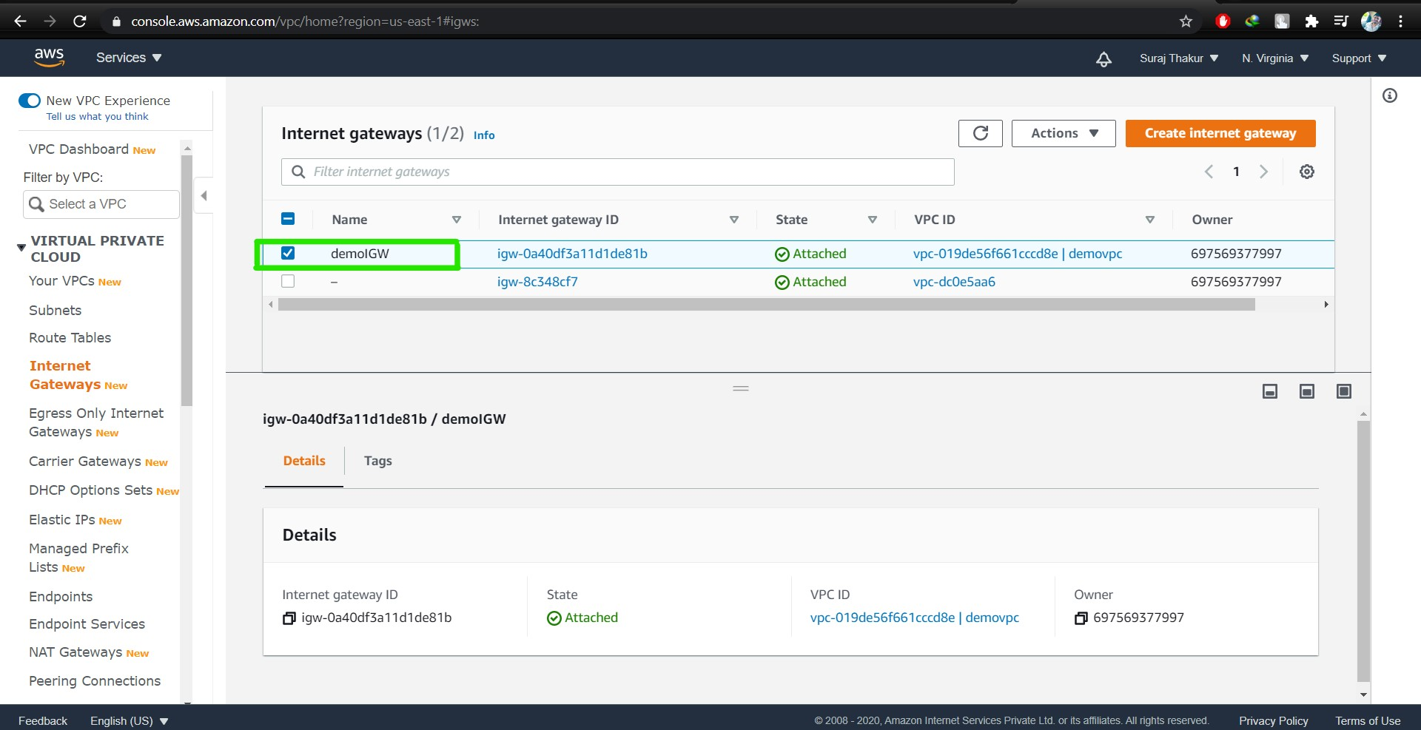

Task3: Create a route table

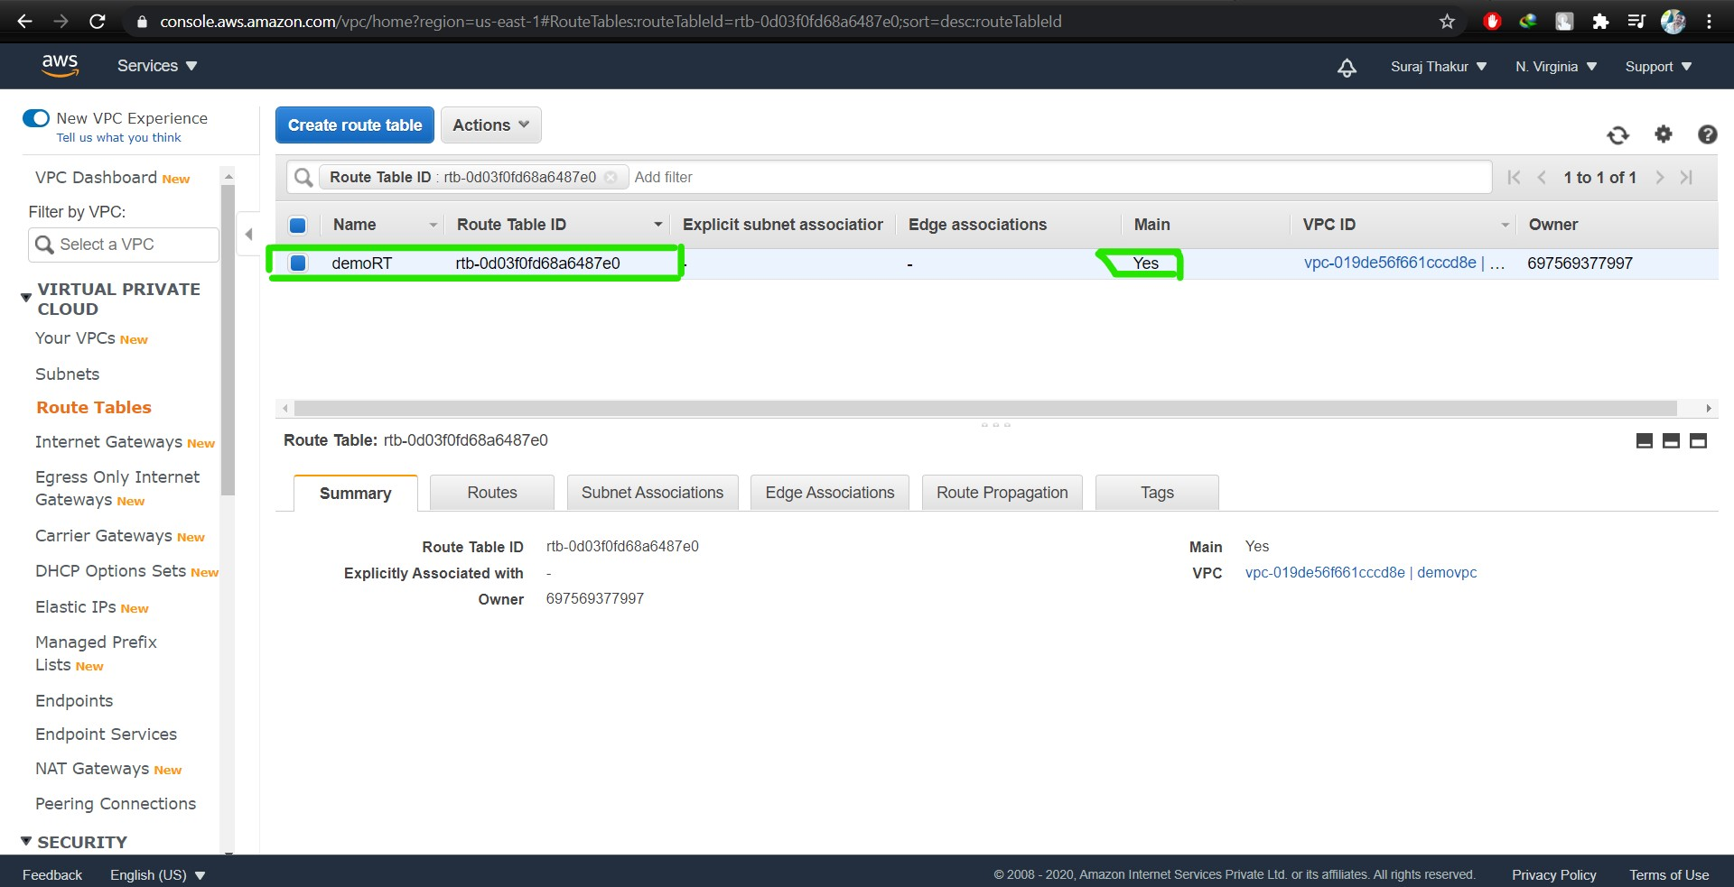

Task4: Create a subnet

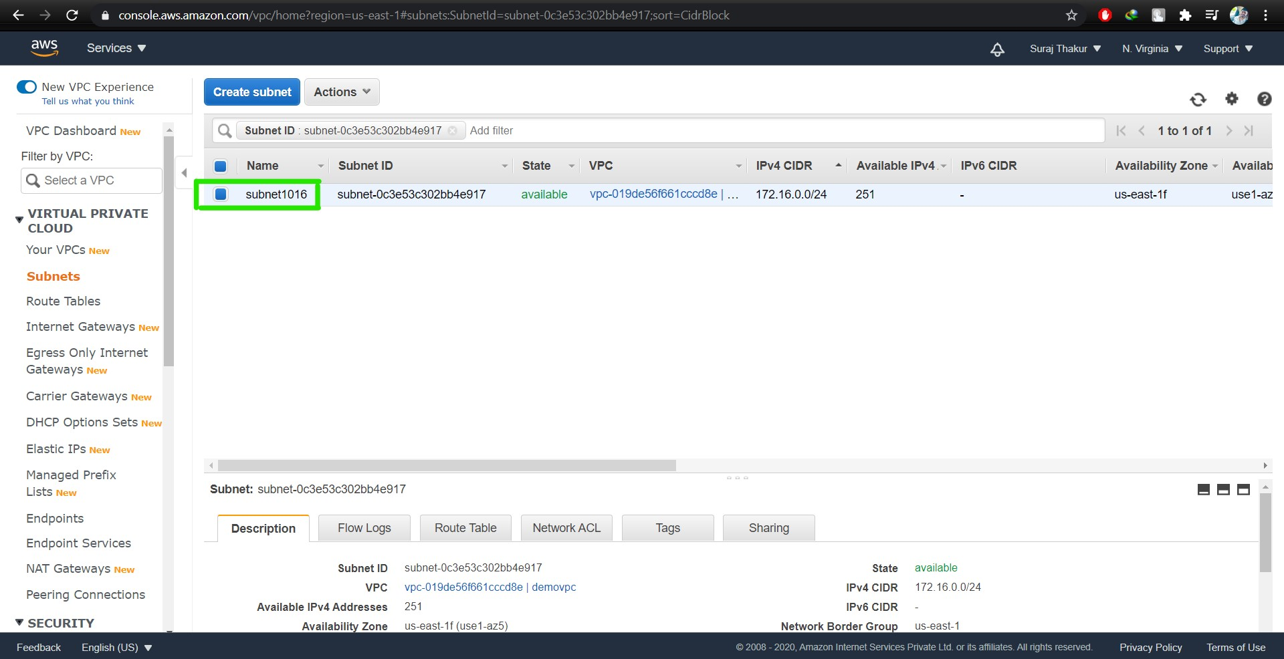

Task5: Create an EC2 in custom vpc

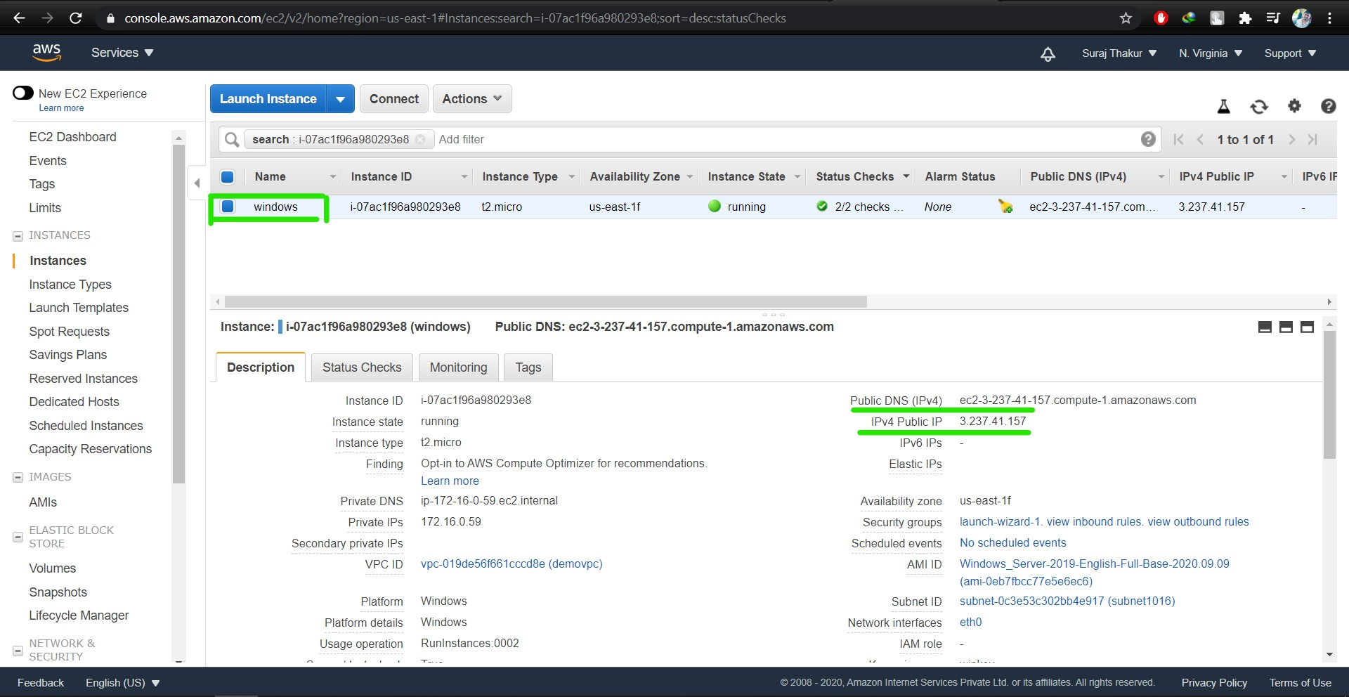

Task 6: Check ipconfig in VM command prompt.

